Field Assessment and Management of Bacterial Leaf Blight, Xanthomonas oryzae pv. oryzae, in Caraga Region

Eliseo H. Batay-an¹ and Cindy A. Burdeos²
¹Consultant and ²Science Research Assistant
Philippine Rice Research Institute, Basilisa, RTRomualdez, Agusan del Norte

ABSTRACT

Field assessment and management studies of Bacterial Leaf Blight (BLB), Xanthomonas oryzae pv. oryzae, were conducted in the farmers’ field in Caraga Region from January 2012 to June 2013. In the field assessment study of BLB infection in the four provinces in Caraga Region, results showed that seven (7) rice varieties were planted by the farmers with BLB infection ranging from 2.96 – 26.57%. PSB Rc82 and NSIC Rc160 obtained the lowest BLB infection with 2.96% and 3.34% suggesting their resistance to BLB infection under natural field condition. Highest BLB infection was recorded in Surigao del Norte in both seasons, followed by Agusan del Norte, Agusan del Sur and Surigao del Sur, respectively. In a separate experiment, seven treatments were laid out in a Randomized Complete Block Design (RCBD) in three replications. Average of three cropping seasons, results revealed that Antica treated plots effectively reduced BLB incidence ranging from 33.08 – 68.31% compared to the other treatments. The low incidence of BLB in Antica treated plots resulted in significantly higher yield of 5.04 t/ha comparable from those plots treated with Armure (4.68 t/ha), Kocide (4.66 t/ha) and Agrilife (4.58 t/ha). The untreated control plots obtained the lowest yield of 3.99 t/ha. Antica treated plots gave a yield advantage of 26.32% over the untreated control.
Yield components such as spikelet number per panicle, panicle length and 1000 grain weight and agronomic parameters such as plant height and number of productive tillers were not affected by the application of the different treatments except on percent filled and unfilled grains where plots treated with Antica produced the highest filled grains of 94.52% with lowest unfilled grains of 5.26%. The untreated control plants had the lowest filled grains of 84.10% with higher unfilled grains of 14.69%. Moreover, plants treated with Antica significantly reduced WSB whiteheads and leaffolder damage during the reproductive phase of the rice plant, however, the application of the different treatments did not affect the population of natural enemies although numerically higher population of natural enemies in Antica treated plots. In terms of the benefits derived from the different treatments, highest net income was recorded from those plants treated with Antica (P56,930.00), followed by Armure (P50,460.00), Kocide (P50,120.00) and Agrilife (P48,700.00) with ROI of 1.98, 1.73, 1.72 and 1.68, respectively.

Keywords: Bacterial Leaf Blight, incidence, yield, yield components, fungicides

INTRODUCTION

Rice, Oryza sativa L., is one of the most important food crops in the world and primary food source of more than one-third of the worlds’ population. More than 90% of the world rice is grown and consumed in Asia where about 60% of the worlds’ people lived (Gnanamanickam et al. 1994). However, rice production is constrained by biotic stresses like diseases with fungal, bacterial and viral origin and one of the bacterial diseases of rice is the Bacterial Leaf Blight.
Bacterial Leaf Blight (BLB), caused by Xanthomonas oryzae pv.oryzae, is one of the most destructive and oldest known diseases of rice in Asia. The primary hosts are rice, species of wild rices (Oryza sativa, O. rufipogon and O. australiensis) and graminaceous weeds, Leersia oryzoides and Zizania latifolia in temperate regions and Leptochloa spp. and Cyperus spp. in the tropics (Mew et al. 1993).
Crop loss assessment studies revealed that BLB reduces grain yield to varying levels, depending on the stage of the crop, degree of cultivar susceptibility and to a great extent the conduciveness of the environment in which it occurs (Gnanamanickam et al. 1999). Yield reduction ranged from 20 - 80% depending on the crop stage when infection occurs. Generally, infection at an earlier stage translates to a higher yield loss, while late infection at booting stage may not be significant but results in poor grain quality and very low head rice recovery.
BLB exhibits three distinct symptoms in the tropics, however, leaf blight symptoms is the most common manifestation seen in the farmers’ field particularly during the wet season wherein the disease is usually prevalent due to strong winds and splashing of windblown rain which contributes to the wounding of plants and favor dissemination of the bacterium from plant to plant. Contaminated stubbles, irrigation water, humans, insects and birds are also sources of infection. Likewise, high humidity and warm temperature are also some of the factors favoring the disease.
In Mindanao, particularly in Caraga Region where the climate belongs to Type II, No pronounced dry season and rainfall is evenly distributed throughout the year, the incidence of BLB infection is very high especially if the variety planted is highly susceptible to the disease. However, at present, no proper documentation and scientific studies have been conducted as to the incidence and severity as well as the management of BLB in the region. Thus, the severity and significance of damages caused by BLB infection have necessitated the development of strategies to control or manage the disease so as to increase yield and reduce crop losses and in turn increase farmers’ profit, protect health and conserve natural resources.
Therefore, this study attempted to assess and document the occurrence of BLB infection in the four provinces of Caraga Region; determine the reaction of the different varieties planted by farmers to BLB infection; compare the effects of organic and inorganic fungicides in the management of BLB and conduct cost and return analysis to determine the profitability of the different treatments and come up with regional recommendations in the management of BLB.
MATERIALS AND METHODS
Activity 1. Assessment of BLB Infection in the Farmers’ Field in Caraga Region
Site Selection
Four Provinces in Caraga Region were chosen for the activity namely: Agusan del Norte, Agusan del Sur, Surigao del Sur and Surigao del Norte. In every Province, at least 2 major rice growing municipalities were selected with 20 farmers’ fields each.

Field Assessment of BLB Infection
Twenty (20) farmers’ fields were selected for each municipality. In each farmer’s field, BLB infection was assessed based on the degree of damage. Twenty five hills were randomly selected based on diagonally transect across fields. Number of infected leaves were counted including the total number of leaves per hill. For percent disease infection, the following formula was followed:

Number of infected leaves per hill
Percent BLB Infection = ---------------------------------------------------- x 100
Total number of infected and
non-infected leaves counted/hill

Other data gathered include the variety planted by the farmers in each municipality per province.

Activity 2. Management of BLB using Organic and Chemical Fungicides

Site Selection and Duration of the study
The experiment was conducted in the farmers field in Tagabaca and Lower Baan, Butuan City, Agusan del Norte, a well-known endemic site for BLB, for three cropping seasons which started in January 2012 and ended in June 2013.

Crop Establishment
A 20 m x 20 m (400 m²) seedbed was used in the study. A 20 kg registered seed of NSIC Rc128 was soaked in clean water for 24 hours and incubated for another 24 hrs then the pre-germinated seeds were uniformly sown into the seedbed at 100 grams per m². Care and maintenance of the seedbed was done. At 21 days after sowing (DAS), the seedlings were carefully pulled and transplanted in the experimental field at a planting distance of 20 cm x 20 cm at 2-3 seedlings per hill. One day after transplanting (DAT), the experimental field was sprayed with molluscicide for the control of golden apple snail (GAS) and 3 DAT, it was sprayed with pre-emergence herbicide for weed management. At 10 DAT, the field was fertilized at 60-30-30 kg NPK per ha. Two-thirds of N and whole of P and K were applied while the remaining one-third N was applied as top dress one week before panicle initiation. The field was continuously flooded at 2-3 cm deep which was later adjusted to 5 cm deep until two weeks before harvest.

Experimental Design
The experiment was laid out in a Randomized Complete Block Design (RCBD) with 7 treatments and three replications. The treatments were: T1 – treated with Antica, T2 – treated with Agrilife, T3 – treated with Trichoderma sp., T4 – treated with Kakawate leaves extract, T5 – treated with Kocide, T6 – treated with Armure and T7 – Untreated control. Plot size was 5 m x 6 m with one meter distance between treatments and replications to prevent treatment contamination during spray application. Variety used was NSIC Rc128 which is susceptible to BLB infection in the area.
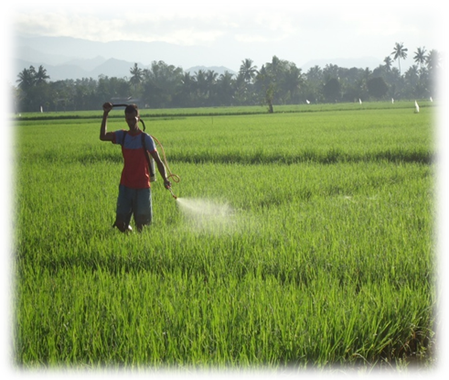
Spray application of the different treatments commenced at 40 days after transplanting (Fig. 1) and repeated at 15 days thereafter until heading stage of the crop. The rate of application was based on Manufacturers’ recommendation and on the results or findings published in Literatures.
Fig. 1. First spray application at 40 DAT

Data gathered include the following:

- BLB Incidence – the following formula was followed:
∑ of infected leaves per hill or quadrat 1-12
BLB incidence = ----------------------------------------------------------------
12 (or number of samples)

where:
% infected leaves per hill is calculated as:

Number of infected leaves per hill
% Infected Leaves = ------------------------------------------------- x 100
Total number of infected + non-
Infected leaves counted per hill

- Yield per plot
This was done by harvesting 2 m x 5 m crop cut at maturity preferably at the center of the experimental plot. Harvested samples were placed in clean sacks for threshing, cleaning, weighing and recording at 14% moisture content.

- Yield Per Hectare
The yield per plot was converted to yield per hectare using the formula:
Weight of harvest
(g) from plot
Corrected Plot Yield = ----------------------------- x total number of hills in harvest area
No. of hills harvested
of a normal plots

100- MC
Adjusted Grain Yield = Corrected Plot Yield (g) x ---------------
86

Adjusted grain yield 10,000 m² 1 kg
Grain Yield (kg/ha) = ------------------------------- x ------------------- x ---------------
Harvest area of normal 1 ha 1000 g
plot (m²)

- Yield Components
  - Spikelet per panicle (No.) – Ten (10) panicles per treatment were randomly selected for the counting of spikelet per panicle. These were placed in plastic bag properly labeled and were brought to the laboratory for counting and recording.
  - Panicle length (cm) – The same panicles were used for the measurement of panicle length using ruler or measuring tape.
  - Panicle weight (g) – The same panicles were used in getting the weight per panicle using digital weighing scale and data were properly recorded.
  - 1000 grain weight (g) – 1000 grains were counted coming from the threshed samples and dried at 14% MC. Dried samples were weighed using digital weighing scale in the laboratory and the weights of the samples were properly recorded.
  - Filled and Unfilled grains (%) – Filled and unfilled grains per panicle were counted and recorded then converted to % filled and unfilled grains using the formula:
No. of filled grains per panicle
% Filled Grains = ----------------------------------------------- x 100
Total no. of filled and unfilled
grains per panicle

No. of unfilled grains per panicle
% Unfilled Grains = ----------------------------------------------- x 100
Total no. of filled and unfilled
grains per panicle

- Agronomic Parameters
  - Plant height (cm) – Ten hills within the treatment plots were randomly selected for the measurement of plant height one week before harvest using meter stick. Collected data were properly recorded.
  - Productive tiller (no.) – The same ten hills were used for the counting of productive tillers per hill one week before harvest. Collected data were properly recorded.

- Other Observations
  - Natural Enemy populations
  - Insect Pests Damage
  - BLB Lesion Length

- Cost and Return Analysis
To determine the profitability of the different treatments, all expenses incurred during the entire duration of the study such as labor and material costs and other costs were properly recorded for the cost and return analysis.
Statistical Analysis
All the data gathered were consolidated, tabulated and analyzed statistically using the STATA Program and subjected to Analysis of Variance (ANOVA). To compare the significant differences among treatment means, Tukeys’ Test was used.

RESULTS AND DISCUSSION

Assessment of BLB Infection in the Farmers’ Field in Caraga Region

Four Provinces in Caraga Region namely: Agusan del Norte, Agusan del Sur, Surigao del Norte and Surigao del Sur were assessed on BLB infection on the different rice varieties planted in the farmers’ field. Percent BLB infection on the different rice varieties planted by farmers in Caraga Region is shown in Fig. 2. Seven varieties were planted in the field namely: NSIC Rc128, NSIC Rc158, PSB Rc18, PSB Rc82, NSIC Rc122, PSB Rc72H and NSIC Rc160. Of the seven rice varieties planted, percent BLB infection ranged from 2.96 to 26.57%. Highest BLB infection was obtained from NSIC Rc128 with 26.57%, followed by PSB Rc18, NSIC Rc122, NSIC Rc158, and PSB 72H with BLB infection of 21.29, 20.93, 20.91, and 17.17 percent respectively. Lower percent BLB infection was obtained in 2013 January to June cropping season.
In contrast, PSB Rc82 and NSIC Rc160 obtained the lowest BLB infection with 2.96% and 3.34% indicating that these varieties were resistant to the disease under

farmers’ field condition in both seasons. The results of this study conform from the findings of Truong et al. (2009) that PSB Rc82 and NSIC Rc154 were among the 36 rice test varieties moderately resistant to at least 5 Xoo races. Likewise, Batay-an and Burdeos (2011) assessed BLB infection in the farmers field in Remedios T. Romualdez, Agusan del Norte. Of the five varieties planted by farmers, PSB Rc82 obtained the lowest BLB infection of 10.82% which indicates that this variety is moderately resistant to the disease under natural field conditions. Other varieties assessed like NSIC Rc128, NSIC Rc122 and PSB Rc18 were moderately susceptible to BLB infection resulting in low yields ranging from 1.41 to 2.96 t/ha.

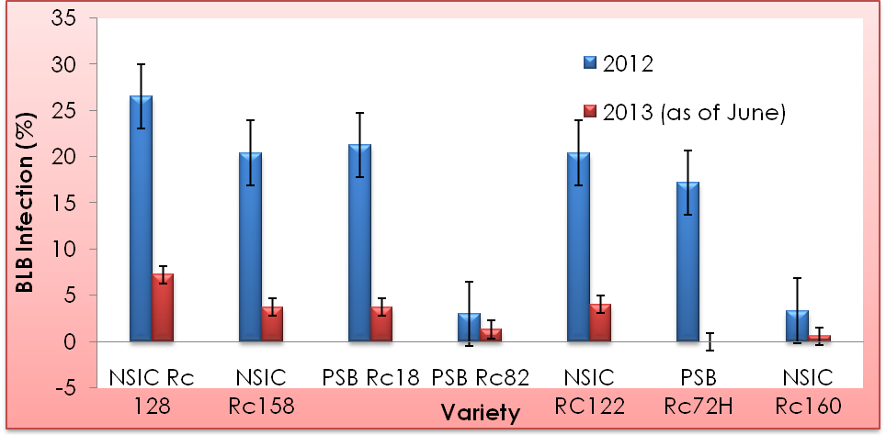
Fig. 2. Percent BLB infection on the different rice varieties planted by farmers in Caraga
Region

In the four provinces in Caraga Region, BLB infection was highest in the province of Surigao del Norte with 43.04%, followed by Agusan del Norte, Agusan del Sur and Surigao del Sur with 38.64%, 11.27% and 7.07% infection, respectively in 2012 cropping season (Fig. 3). However, in 2013 cropping season, lower BLB infection was observed although similar trend was noted. High BLB infection in Surigao del Norte was attributed to asynchronous planting practiced in the area, planting of susceptible varieties such as NSIC Rc128 and PSB Rc18, and higher rainfall observed during the conduct of the study which favors the multiplication of the Xoo pathogen as compared to other provinces.

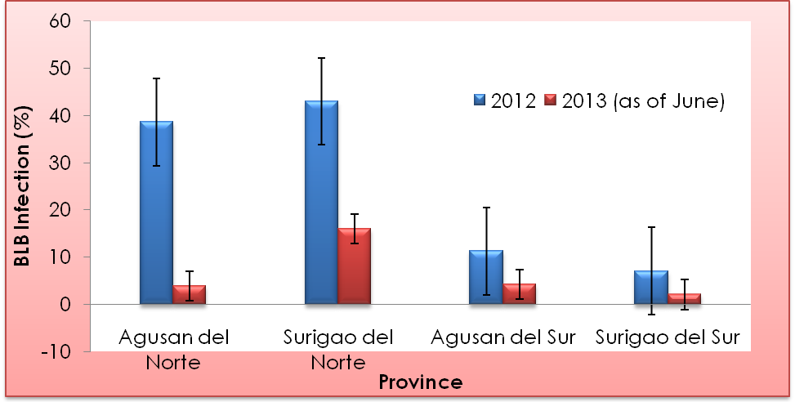
Fig. 3. Percent BLB Infection in the farmers field in the four provinces in Caraga
Region

Management of Bacterial Leaf Blight (BLB) using organic and inorganic fungicides in the farmers’ field

Effect of the different treatments on Bacterial Leaf Blight (BLB) Incidence
Fig. 4. shows the effect of the different treatments on the incidence of BLB in the farmers’ field in Tagabaca and Lower Baan, Butuan City, Agusan del Norte for three cropping seasons. One month after transplanting (DAT), disease symptoms was already evident thus spray application started at 40 DAT and repeated at 15 days thereafter until the heading stage of the rice plants. Data gathered at two weeks before harvest showed that BLB incidence in plots treated with Antica exhibited the lowest incidence of the disease during the first cropping season which resulted to highly significant differences compared to the other treatments. During the second cropping season, Antica treated plots registered the lowest BLB incidence although it was comparable from those plots treated with Kocide, a chemical fungicide known as copper hydroxide. Other treatments evaluated had higher BLB incidence although the untreated control obtained the highest incidence of the disease. Similar trend was also noted in the third cropping season wherein those plots treated with Antica significantly obtained the lowest BLB incidence, however, it was not significantly different from those plots treated with Kocide, Armure and Agrilife, respectively. It was very apparent that the untreated control obtained the highest BLB incidence in all the three cropping seasons. The result suggests that the application of Antica significantly reduced the incidence of BLB disease in the farmers field because consistently for three successive seasons, the Antica treated plots proved effective in reducing BLB incidence (Fig. 4 ).

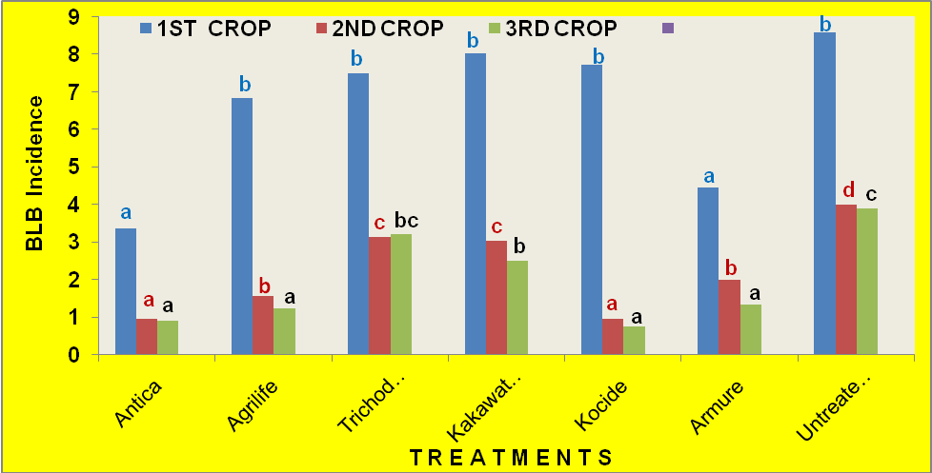
Fig. 4. Effect of different treatments on BLB incidence in three cropping seasons in the
farmers field in Agusan del Norte, Jan. 2012 – June 2013. Bars having the same
letter and color are not significantly different at 5% level by Tukeys Test.

Average of BLB incidence in three cropping seasons is presented in Fig. 5. Result shows that rice plants applied with Antica significantly reduced BLB incidence (1.74) in the farmers’ field which was very apparent in Fig. 6. However, it was comparable from those plants applied with Armure (2.60), Kocide (3.15) and Agrilife (3.22), respectively. The findings of this study was similar with the results of Uba (2010) that in vitro test of different rates of Antica against Xanthomonas oryzae pv. oryzae (Xoo) revealed comparable effect to Kocide inorganic check. All test treatments were found effective to very effective and the highest degree of control was demonstrated by Antica at 34.25% which significantly increased the yield of PSB Rc72H. On the other hand, the results of this study also conform from the findings of Gergon and Amar (2011) that the application of Antica is effective in reducing the incidence and severity of BLB and Bacterial leaf streak (BLS) of rice.
In this study, the untreated control plants significantly obtained the highest BLB incidence of 5.49 which was very evident in Fig. 7. The result implies that the incidence of BLB obtained from those plants applied with Antica was 68.31% lower than those obtained in the untreated control plants.

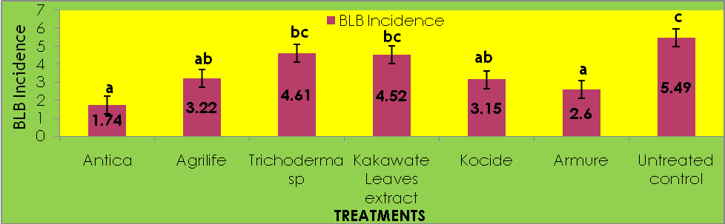
Fig. 5. BLB incidence in NSIC Rc128 as affected by the application of the different treatments. Average of three cropping seasons in Tagabaca and Lower Baan, Butuan City, Agusan del Norte, January 2012 – June 2013. Bars having the same letter are not signiicantly different at 5% level by Tukeys’ Test

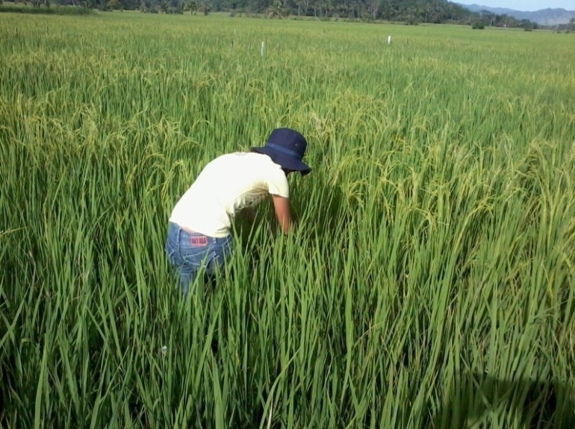
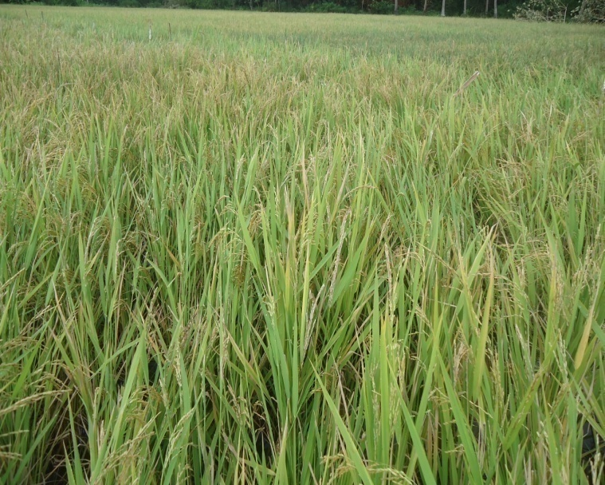
Fig. 6. Antica treated plot at
heading stage

Fig. 7. Untreated control at
heading stage

Effect of the different treatments on the yield of NSIC Rc128 in t/ha
Fig. 8 shows the yield of NSIC Rc128 in t/ha for three successive cropping seasons in the farmers field in Tagabaca and Lower Baan, Butuan City. In the first cropping season, plots treated with Antica produced the highest yield but did not significantly differ with those plots treated with Armure, Agrilife and Kocide. Lowest yield was obtained in the untreated control plots but did not differ from those plots treated with Trichoderma sp. suggesting that Trichoderma sp. is less effective in reducing BLB incidence in the farmers field. For the second cropping, similar trend was noted. The Antica treated plots significantly produced the highest yield as compared to all the treatments evaluated except those plots treated with Agrilife and Kocide. Other treatments were comparable with the untreated control plots. In the third cropping season, Antica treated plots outyielded all the other treatments, however, it was not significantly different from those plots treated with Kocide, Armure, and Agrilife. The results obtained in these three season data consistently showed that rice plants treated with Antica produced the highest yield ranging from 4.99 – 5.11 t/ha while the untreated control plots produced the lowest yield of 3.85 – 4.07 t/ha (Fig. 8).
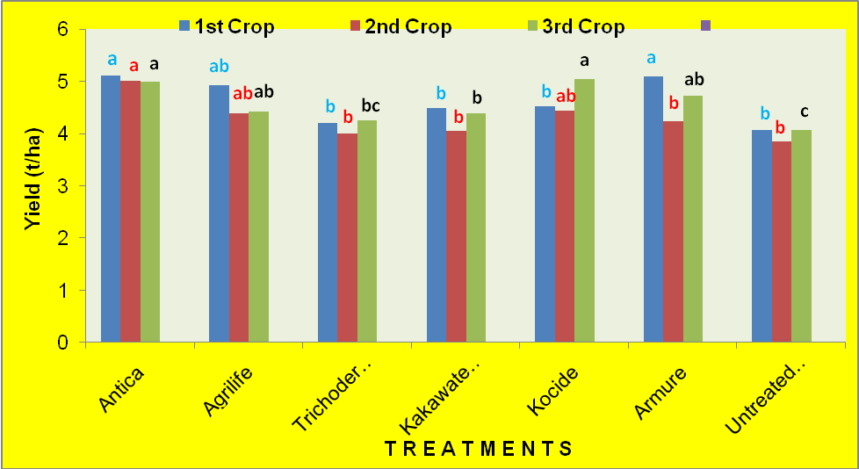
Fig. 8. Yield of NSIC Rc128 in t/ha for three cropping seasons in the farmers’ field,
Jan. 2012 – June 2013. Bars having same letter and color are not significantly different at 5% level by Tukeys Test.

The average yield obtained in three cropping seasons as affected by the different treatments is shown in Fig. 9. The yield of NSIC Rc128 in tons per ha showed that rice plants applied with Antica significantly produced the highest mean yield of 5.04 t/ha comparable from those plants applied with Armure, Kocide, Agrilife and Kakawate leaves extract with yields of 4.68 t/ha, 4.66 t/ha, 4.58 t/ha, and 4.31 t/ha, respectively. The untreated control plants obtained the lowest yield of 3.85 t/ha but comparable with all the treated plants except those plants applied with Antica. High yields obtained from those plants applied with Antica, Armure, Kocide and Agrilife were attributed to the very low BLB incidence ranging from 1.74 – 3.22 (Fig. 4 and 5) and high percent filled grains ranging from 92 – 95% (Table 2). In addition, plots treated with Antica gave the highest yield advantage of 26.32% over the untreated control followed by plots treated with Armure, Kocide and Agrilife with yield advantages of 17.29, 16.79 and 14.79%; respectively (Table 1).
On the other hand, lower yield was obtained from those plants with high BLB incidence due to the reduction of the plants’ photosynthetic capacity as a result of reduced leaf area index. The lesions on the leaves significantly reduced the leaf area required for photosynthetic activity (Agribusiness Week 2008). This is also true especially if the flag leaf of the rice plants is infected with BLB since the flag leaf is responsible for the photosynthetic activity for the grain filling responsible in obtaining higher yield.
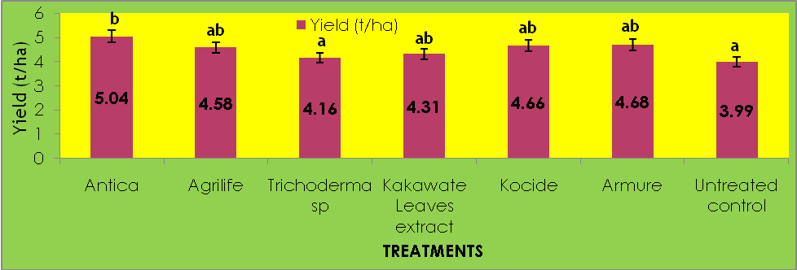
Fig. 8. Average yield of NSIC Rc128 (t/ha) in three cropping seasons as affected by the application of the different treatments in Tagabaca and Lower Baan, Butuan City, Agusan del Norte, 2012-2013. Bars having the same letter are not significantly different at 5% level by Tukeys’ Test.

Table 1. Percent change in grain yield of NSIC Rc128 as affected by the different
treatments, January 2012 – June 2013

TREATMENTS Grain Yield (t/ha)¹ Percent Change

Antica 5.04 26.32

Agrilife 4.58 14.79

Trichoderma sp. 4.16 4.26

Kakawate leaves extract 4.31 8.02

Kocide 4.66 16.79

Armure 4.68 17.29

Untreated control 3.99 -

¹ Ave. of 3 cropping seasons

Effect of the different treatments on yield components
The yield components of NSIC Rc128 as affected by the application of the different treatments is shown in Table 2. No significant differences were obtained on the number of spikelets per panicle. Spikelet number per panicle ranged from 328 – 374 spikelets. Similarly, panicle length did not show significant differences among the various treatments. However, panicle length was numerically higher from those plants applied with Antica (32.45 cm), followed by plants applied with Agrilife, Trichoderma sp, Armure, Kakawate leaves extract, and Kocide with 30.65, 27.16, 27.15, 27.15 and 23.47 cm, respectively. The untreated control plants registered the lowest panicle length of 22.98 cm. No significant differences were also noted in 1000 grain weight. However, plants applied with Antica numerically obtained the highest 1000 grain weight of 22.83 g (Table 2) while the untreated control plants obtained the lowest 1000 grain weight with 21.92 g. On the other hand, significant differences among treatment means were obtained on percent filled and unfilled grains. Plants applied with Antica significantly obtained the highest filled grains of 94.52%, comparable from those plants applied with Kocide, Agrilife, Armure and Kakawate leaves extract with 92.64, 92.40, 91.79 and 91.78 %, respectively. The untreated control plants produced the lowest filled grains with 84.10% but not significant from those plants applied with Trichoderma sp with 88.44% (Table 2) On the other hand, plants applied with Antica significantly obtained the lowest unfilled grains of 5.48% comparable from those plants applied with Kocide, Agrilife, Armure and Kakawate leaves extract with 7.36, 7.60, 8.16 and 8.22% unfilled grains, respectively. The untreated control plants obtained the highest unfilled grains of 15.90% but not significant from those plants applied with Trichoderma sp. with 11.46% unfilled grains, suggesting that Trichoderma sp. is not effective in reducing the percent unfilled grains of rice.
Effect of the different treatments on agronomic parameters
The agronomic parameters as affected by the different treatments is also shown in Table 2. No significant variations were obtained on plant height. This indicates that the different treatments applied to the rice plant did not affect plant height. Plant height ranged from 93.20 – 94.93 cm.
No significant differences were also noted among treatments on the number of productive tillers per hill. Number of productive tillers ranged from 14.80 -15.24 tillers per hill (Table 2). The results simply mean that the different treatments applied to the rice plant did not significantly increase plant height and number of productive tillers per hill.
Table 2. Yield Components and Agronomic Parameters as affected by the application of the different treatments¹. Tagabaca and Lower Baan, Butuan City, Jan. 2012 - June 2013.

TREATMENTS | AGRONOMIC  PARAMETERS Y I E L D C O M P O N E N T S
TREATMENTS | Plant Produc- Spikelet/ Panicle 1000 Filled Unfilled  Height tive panicle length grain grains grains  (cm) tiller (No.) (cm) weight (%) (%)  (No.) (g)
Antica  Agrilife  Trichoderma sp.  Kakawate Leaves  Extract  Kocide  Armure  Untreated control | 94.33ns 15.24ns 362ns 32.5ns 22.83ns 94.52a 5.48a  94.05 14.92 361 31.0 22.55 92.40a 7.60a  94.93 14.93 358 27.2 21.98 88.44 b 11.46 b  93.20 15.13 374 26.8 22.09 91.78a 8.22a  94.02 15.05 345 23.5 22.39 92.64a 7.36a  93.90 15.00 328 27.2 23.26 91.79a 8.16a  94.37 14.80 341 22.9 21.92 84.10 b 15.90 b

¹Ave. of 3 replications. Average of three cropping seasons, means followed the same letter are not significantly different at 5% level by Tukeys’ Test.
ns – not significant

Effect of the different treatments on insect pests damage
Table 3 shows the percent damage caused by different insect pests of rice as affected by the application of the different treatments. Two rice insect pests were observed in the experimental field namely: White stemborer, Scirpophaga innotata Walker and Rice Leaffolder, Cnaphalocrocis medinalis Guenee. White stemborer (WSB) larvae damaged the rice plant during the vegetative and reproductive phases. At the vegetative phase, wilting and drying of the youngest shoot were observed known as “deadheart” and at the reproductive phase, unfilled panicles and empty grains known as “whiteheads”. During the vegetative phase, percent deadheart damaged did not show
significant differences among treatment means. Deadheart damaged caused by WSB ranged from 10.84 – 13.33%. At the reproductive phase, significant variations were observed among the different treatments with plants applied with Antica exhibited the lowest whitehead damage (17.24%), followed by Armure (17.59 %), Kocide (17.77 %), Kakawate leaves extract (20.01 %), Agrilife (22.96 %) and Trichoderma sp (22.98 %), respectively. Highest whitehead damage was obtained from the untreated control plants with 29.19%.
On the other hand, significant differences among treatments were also observed on the damage caused by leaf folder at the reproductive phase of the rice plant. Plant applied with Kakawate leaves extract obtained the lowest leaf folder damage of 9.89% comparable with those plants applied with Antica, Armure and Kocide with 10.68%, 13.25% and 15.76%, respectively. The untreated control plants obtained the highest leaf folder damage of 20.38% comparable from those plants applied with Kocide, Agrilife and Trichoderma sp.(Table 3).

Table 3. Insect Pest damage caused by white stem borer and leaf folder as affected by the application of the different treatments¹.Tagabaca and Lower Baan, Butuan City, Jan. 2012 - June 2013.
TREATMENTS | Deadheart  (%) | Whitehead  (%) | Leaf folder damage (%)
Antica  Agrilife  Trichoderma sp.  Kakawate Leaves extract  Kocide  Armure  Untreated control | 11.85 ns  13.33  11.11  10.84  11.85  13.33  , 11.11 | 17.24 b  22.96 ab  22.98 ab  20.21 ab  17.77 b  17.59 b  29.19 a | 10.68 ab  16.07 bc  16.37 bc  9.89 a  15.76 abc  13.25 ab  20.38 c

¹Ave. of 3 replications. Ave. of three cropping seasons, means followed by the same letter are not significantly different at 5% level by Tukeys test
ns – not significant

Effect of the different treatments on BLB lesion length
Fig. 9 shows the length of BLB lesions as affected by the application of the different treatments. Significant differences among treatment means were obtained on the length of BLB lesions. Rice plants applied with Antica significantly produced the shortest lesion length of 4.26 cm comparable from those plants applied with Kocide, Armure and Agrilife with lesion lengths of 4.80, 5.06 and 5.40 cm, respectively. The result indicates that the application of Antica. Kocide, Armure and Agrilife significantly reduced the lesion length of BLB thereby effectively reducing BLB incidence. Plants applied with Trichoderma sp. and Kakawate leaves extract had higher lesion lengths with 12.73 and 12.93 cm, but significantly lower when compared with the untreated control plants. The longest lesion length was obtained in the untreated control plants with 20.20 cm wherein almost all the leaf area of the sampled leaves were totally infected with BLB (Fig. 9).
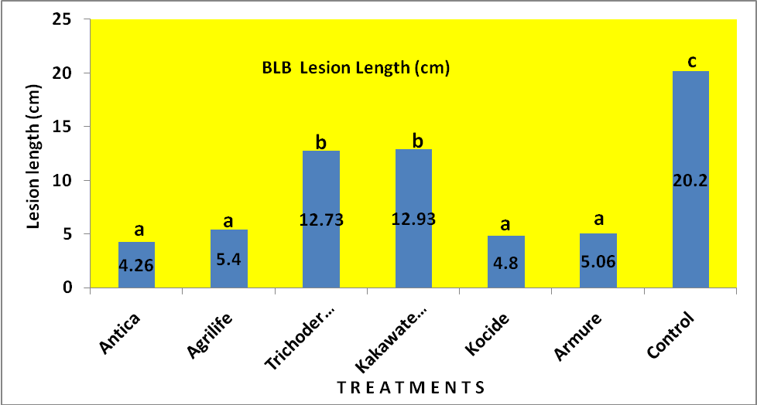
Fig. 9. BLB Lesion length (cm) as affected by the application of the different treatments.
Average of three cropping seasons in the farmers’ field in Tagabaca and Lower Baan, Butuan City, Jan. 2012 – June 2013. Bars having the same letter are not
significantly different at 5% level by Tukeys’ Test

Effect of the different treatments on natural enemy populations
The population of natural enemies collected by sweep net were not significantly affected by the application of the different treatments. The most abundant species of natural enemies collected were predators such as ladybird beetles and spiders and parasitoid wasps (Table 3). Population of ladybird beetles ranged from 3.33 – 7.66 adults per 10 sweeps while spider populations ranged from 1.0 – 3.33 adults per 10 sweeps, respectively. The population of parasitoid wasps was also low ranging from 2.00 – 6.66 adults per 10 sweeps although Antica treated plots had numerically higher natural enemy populations observed. The result implies that Antica is safe to use in the field because the beneficial arthropods that play a vital role in pest management were not affected. The abundant species of coccinellid beetles collected were Chilomenes sexmaculata (Fabr.) and Micraspis discolor (Fabr.) while spider species collected in the experimental field were Tetragnatha sp., Oxyopes sp., and Argiope sp., respectively. Parasitoid wasps collected by sweep net were Temelucha philippinensis, Trichomma cnaphalocrocis, Itoplectis narangae and other Ichneumonid wasps.

Table 3. Population of Natural Enemies as affected by the application of the different treatments¹. Tagabaca and Lower Baan, Butuan City, Jan. 2012 – June 2013
T R E A T M E N T S |  | NATURAL ENEMIES*
T R E A T M E N T S |  | Lady beetles | Spiders | Wasps
Antica  Agrilife  Trichoderma sp.  Kakawate leaves extract  Kocide  Armure  Untreated Control |  | 7.66 ns  3.33  6.00  7.33  3.33  3.67  4.00 | 3.33 ns  2.00  1.00  2.00  1.33  2.33  1.00 | 5.66 ns  3.66  5.00  3.00  2.66  2.00  6.66

¹Ave. of three cropping seasons ns- not significant *No. per 10 sweeps

Cost and Return Analysis of the different treatments
To determine the profitability of the different treatments, cost and return analysis was done. Average of three cropping seasons showed that the different treatments obtained varying results. Rice plants applied with Antica obtained the highest gross income of P85,680.00, followed by plants applied with Armure, Kocide, Agrilife, , Kakawate leaves and Trichoderma sp. with P79,560.00, P79,220.00, P77,860.00, P73,270.00 and P70,720.00, respectively. The untreated control plants obtained the lowest gross income of P67,830.00. However, in terms of net income, the same trend was noted wherein the plants treated with Antica obtained the highest net income of P56,930.00 followed by plants treated with Armure (P50,460.00). Kocide (P50,120.00), Agrilife (P48,760.00), Kakawate leaves extract (P44,870.00) and Trichoderma sp. (P42,320..00) and the lowest was obtained in the untreated control plants with P40,580.00. The result implies that the application of Antica, Armure, Kocide and Agrilife to the rice plant did not only increase the yield of rice but also increase net income with return of investment (ROI) of 1.98, 1.73, 1.72 and 1.68, respectively (Table 4). The untreated control obtained the lowest ROI of 1.48.

Table 4. Cost and Return Analysis as affected by the different treatments¹
PARTICULARS | ANTICA | AGRILIFE | Trichoderma | KAKAWATE | KOCIDE | ARMURE | CONTROL
Yield (kg/ha* | 5,040 | 4,580 | 4,160 | 4,310 | 4,660 | 4,680 | 3,990
Gross Income | 85,680 | 77,860 | 70,720 | 73,270 | 79,220 | 79,560 | 67,830
Material Cost | 8,150 | 8,500 | 7,800 | 7,500 | 8,500 | 8,500 | 7,100
Labor Cost | 20,600 | 20,600 | 20,600 | 20,900 | 20,600 | 20,600 | 20,150
Total Expenses | 28,750 | 29,100 | 28,400 | 28,400 | 29,100 | 29,100 | 27,250
NET INCOME | 56,930 | 48,760 | 42,320 | 44,870 | 50,120 | 50,460 | 40,580
ROI | 1.98 | 1.68 | 1.49 | 1.58 | 1.72 | 1.73 | 1.48

¹Ave. of three cropping seasons *P17.00/kg price of dried palay

SUMMARY AND CONCLUSION

In the assessment study of BLB infection in the four provinces in Caraga Region, seven (7) rice varieties were planted by the farmers with varying degrees of infection ranging from 2.96 – 26.57%. PSB Rc82 and NSIC Rc160 obtained the lowest BLB infection with 2.96 and 3.34% indicating their resistance to BLB under natural field condition. BLB infection recorded was highest in Surigao del Norte, followed by Agusan del Norte, Agusan del Sur and Surigao del Sur and also higher BLB infection during the January to June cropping season than July to December cropping season, respectively.
In the management of BLB in the farmers’ field in Agusan del Norte for 3 cropping seasons, rice plants applied with Antica, an organic fungicide, was the most effective in reducing the incidence of BLB thereby increasing the yield of rice with a yield advantage of 26.32% compared to the untreated control. Rice plants applied with Antica obtained the highest filled grains of 94.52% and lowest unfilled grains of 5.26% while the untreated control plants obtained the lowest percent filled grains (84.10%) and highest percent unfilled grains (14.69%).
Moreover, white stemborer whiteheads and leaf folder damage at reproductive phase of the rice plant was significantly reduced by the application of Antica. However, it did not affect the population of natural enemies. To determine the profitability of the different treatments, cost and return analysis showed that highest net income of P56,930.00 was obtained from those plants applied with Antica, followed by Armure (50,460.00), Kocide (P50,120.00) and Agrilife (P48,760.00), respectively.
Based on the findings of this study, it can be concluded that PSB Rc82 and NSIC Rc160 obtained the lowest percent BLB infection in the farmers’ field in the four provinces in Caraga Region indicating their resistance to BLB. In terms of BLB management, the application of Antica did not only reduce the incidence of BLB but also reduced the damage caused by WSB whitehead and leaffolder damage resulting in increased grain yield and income with return of investment of 1.98.

LITERATURE CITED

BABB, M.G.M., M.J. DUQUE, J.G. CASTRO, L.M. PEREZ, J.T. NIONES, G.B. AMAR, A.A. DELA CRUZ, E.D. ESPEJO, J.C. DUQUE, T.H. XUAN, F.A. DELA PEŇA and L.M. BORINES . 2007. Characterization of Prevalent Races of Xanthomonas oryzae pv. oryzae in Major Inbred and Hybrid Rice Growing Areas in the Philippines. In: Philippine Rice R&D Highlights, 2007, PhilRice Maligaya, Science City of Muñoz, Nueva Ecija, pp. 113-114.
BATAY-AN, E. H. and C. A. BURDEOS. 2012. Assessment of Bacterial Leaf Blight, Xanthomonas oryzae pv. oryzae, Infection in Remedios T. Romualdez, Agusan del Norte. A poster paper presented during the 25th National Rice R&D Conference held at PhilRice Maligaya, Science City of Muñoz, Nueva Ecija on Sept. 4-6, 2012.
BATAY-AN, E. H., A. A. ORTIZ and A. B. ESTOY. 2004. Evaluation of different chemicals for Bacterial Blight Management in F1 Hybrid Rice Cultivation. Poster paper presented during the 35th Crop Science Society of the Philippines (CSSP) Annual Conference, March 8-12, 2004, Waterfront Hotel, Lanang, Davao City.
GERGON, E.B., and G.B. AMAR. 2011. Field Evaluation of Antica for the Management of Rice Bacterial Leaf Blight and Tungro. In: Agriculture Magazine March Issue by Zac B. Sarian.
GNANAMANICKAM, S. S., V. BRINDHA PRIYADARISINI, N.N. NARAYANAN, PREETI VASUDEVAN and S. KAVITHA. 1999. An Overview of Bacterial Blight Disease of Rice and strategies for its management. In: Current Sci. Vol. 77 # 11: 1435-1443.
GNANAMANICKAM, S.S., T. SHIKAGI, E.S. MEDALLA, T.W. MEW, and A.M. ALVAREZ. 1994. Plant Diseases. In: Current Science, Vol. 78, pp. 173- 178.
MEW, T. M., A. M. ALVAREZ, J. E. LEACH, and J. SWINGS. 1993. Focus on bacterial blight of rice. In: Plant Diseases, Vol. 77: 5-12.
TRUONG, H. X., G. M. BABB, I. MODINA, M.J.C. DUQUE, and M.D. DUQUE. 2009. Characterization of Xanthomonas oryzae pv. oryzae Races in Major Rice Growing Areas. In: Philippine Rice R&D Highlights 2009, PhilRice Maligaya, Science City of Muñoz, Nueva Ecija, pp. 87-88.
UBA, J. A. 2010. Efficacy of seven rates of Antica against Xanthomonas oryzae pv. oryzae (Ishiyama) Swing et al. causing bacterial leaf blight of rice. Undergraduate Thesis, University of Southern Mindanao, Kabacan, North Cotabato, 50 p.

